**Table of Contents**

SECTION

1 Arrivals 2

Arrivals by Quarter 3

Arrivals by Month 5

Arrivals by Part of Day 7

Arrivals by Hour 9

Arrivals by 10 Most Popular Origin Cities 11

2 Arrivals 15 Minutes Late 12

Arrivals that Arrived at Least 15 Minutes Late by Quarter 13

Arrivals that Arrived at Least 15 Minutes Late by Month 14

Arrivals that Arrived at Least 15 Minutes Late by Part of Day 15

Arrivals that Arrived at Least 15 Minutes Late by Hour 16

Arrivals that Arrived at Least 15 Minutes Late by Origin City 17

3 Arrivals by Airline 18

Arrivals Cancelled by Airline 19

Arrival Delay Length by Airline 20

Arrivals Delayed 15 Minutes by Airline 21

4 Southwest Arrivals 22

Southwest Arrivals by Quarter 23

Southwest Arrivals by Month 25

Southwest Arrivals by Part of Day 27

Southwest Arrivals by Hour 29

Southwest Arrivals by Origin City 31

5 Conclusion 32

**Arrivals**

Albany International Airport had 15,553 flights arrive in 2024. The median was 0 minutes arrived after the scheduled time. On average, flights arrived 17 minutes late. (The median should be a better estimate of the typical delay time because 15% of the delay minutes variable’s values were outliers and when that is above 5%, the median is likely better than the mean. This is because a couple large delay times can make the mean large and bigger than the typical delay length.)

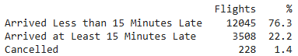

The above pie chart is for all flights scheduled to arrive at Albany International Airport. The vast majority arrived and did not arrive at least 15 minutes late.

**Arrivals by Quarter:**

The best quarter to arrive to Albany International Airport was the fourth with an average arrival delay of 15 minutes and 75% of arrivals arriving about 8 minutes delayed or less. The third quarter was the worst with an average of 21 minutes delayed.

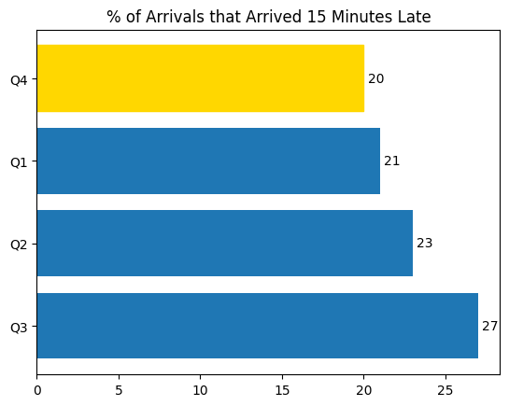

Another way to evaluate arrival delays by quarter is to look at the percent of arrival flights that arrived at least 15 minutes late. The best quarter to arrive was still the fourth quarter with 20% of arrivals arriving at least 15 minutes late. The worst quarter to arrive was the third quarter with 27% of arrivals arriving at least 15 minutes late and 2% of scheduled arrival flights cancelled for that quarter. (The percents are different from the table and graph because the table is the percent of all scheduled arrivals that arrived 15 minutes late, while the graph is the percent of scheduled arrivals that were not diverted or cancelled that arrived 15 minutes late).

**Arrivals by Month**

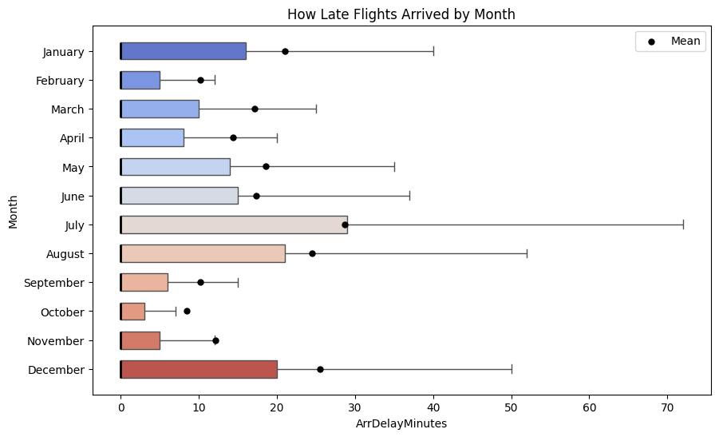

The worst month to arrive to Albany International Airport based on mean was July with arrivals arriving about 29 minutes late on average, while October was the best with 75% of arrivals arriving about 2 minutes or less with an average arrival delay of 8 minutes delayed.

Another way to evaluate delays by month is to look at the percent of arrival flights that were that arrival delays of at least 15 minutes. The worst month to depart was July with 33% of arrivals arriving at least 15 minutes late and 4% of scheduled arrivals cancelled. The best months were October and February with about 14% of arrivals and scheduled arrivals arriving at least 15 minutes late and 1% of scheduled arrivals cancelled.

**Arrivals by Part of Day**

The worst part of the day to arrive to Albany International Airport was the evening with an average of 23 minutes delayed, while the morning was the best with 75% of arrival flights in the morning delayed about 2 minutes or less and an average arrival delay of 12 minutes.

Another way to evaluate arrivals by part of the day is to look at the percent of arrival flights that were delayed at least 15 minutes. The worst part of the day to arrive was still the evening with 28% of scheduled arrival flights arriving at least 15 minutes late and 2% of scheduled arrivals cancelled. The best part of the day to arrive was still the morning with 15% of arrivals delayed at least 15 minutes.

**Arrivals by Hour**

Based on mean minutes delayed, the worst hour to arrive to Albany International Airport was the 2100 hour (9-9:59 pm) with an average arrival delay of 36 minutes. The best hour to arrive was the 8am hour with an average arrival delay of about 4 minutes.

Another way to evaluate arrival delays by hour is to look at the percent of arrival flights that were delayed at least 15 minutes. The worst hour to arrive was the 0001-0559 hour (1 am - 5:59 am) with 39% of arrivals arriving at least 15 minutes late and 3% cancelled. The best hours were the 8 am and 9 am hours with 10% of arrival flights delayed at least 15 minutes and 1% of scheduled flights cancelled.

**Arrivals by 10 Most Popular Origin Cities**

Out of the ten most popular cities to fly to from Albany International Airport, arrival flights to NYC had the smallest mean minutes delayed, arriving 11 minutes late on average, and over 75% of arrivals arriving about 5 minutes late or less. Arrival flights to Charlotte, NC had the highest mean minutes delayed, arriving about 23 minutes late on average.

Another way to evaluate arrivals to the ten most popular destinations is to look at the percent of arrival flights that were delayed at least 15 minutes. Arrival flights to Newark, NJ had the smallest percentage of flights delayed at least 15 minutes, 14% of flights arrived at least 15 minutes late, but 3% of arrival flights were cancelled. Arrival flights to Baltimore, MD had the highest percent of 15-minute delays, 29% were delayed at least 15 minutes.

**Arrivals 15 Minutes Late**

Albany International Airport had 3,508 arrival flights arrived at least 15 minutes late in 2024. The median was arriving 40 minutes late. On average, these flights arrived 73 minutes late. (The median should be a better estimate of the typical delay time because 8% of the delay lengths were outliers and when that is above 5%, the median is likely better than the mean for typical delay length. This is because a couple large delay times can make the mean large and bigger than the typical delay length).

**Arrivals that Arrived at Least 15 Minutes Late by Quarter**

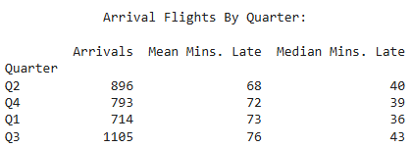

**Arrivals that Arrived at Least 15 Minutes Late by Month**

**Arrivals that Arrived at Least 15 Minutes Late by Part of Day**

**Arrivals that Arrived at Least 15 Minutes Late by Hour**

**

**Arrivals by Airline**

Southwest, Piedmont Airlines, and American Airlines were the most popular airlines for scheduled arrivals to Albany International Airport. Southwest more than doubled the percent of scheduled arrivals that Piedmont had. (Percent of Scheduled Flights is number of scheduled flights for the airline divided by total number of scheduled flights to Albany International Airport).

**

**

**

**Southwest Arrivals**

On average, Southwest flights in 2024 arriving in Albany International Airport were 15 minutes delayed, with a median of 0 minutes delayed. (The median should be a better estimate of the typical delay time because 11% of the delay minutes variable’s values were outliers and when that is above 5%, the median is likely better than the mean. This is because a couple large delay times can make the mean large and bigger than the typical delay length.)

**Southwest Arrivals by Quarter**

**Southwest Arrivals by Month**

**Southwest Arrivals by Part of Day**

**Southwest Arrivals by Hour**

**Southwest Arrivals by Origin City**

**Conclusion**

Based on the data I gathered, the best time to arrive to Albany International Airport in 2024 was September in the morning during the 8am hour. Out of the months with 0% of scheduled arrivals cancelled, September was the month with the lowest mean minutes late. The morning was the part of day with the lowest mean minutes late and 75% of arrivals arrived less than 5 minutes late. The 8am hour had the lowest mean minutes late and 75% of arrivals arrived about 0 minutes late. If you are flying in 2025, it could be wise to choose this time.

If you were flying Southwest, the best time to arrive to Albany International Airport in 2024 was November in the afternoon during the noon hour. November and the afternoon had the lowest mean minutes late for their respective groups and the afternoon had a lower percent of cancellations compared to the morning. The noon hour had the lowest mean minutes late for the afternoon hours. If you are flying in 2025, it could be wise to choose this time.